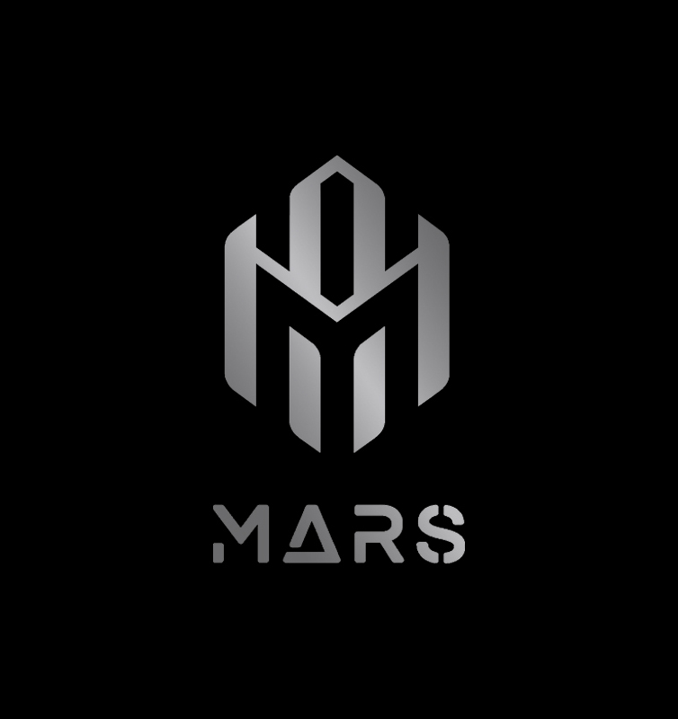
Market Analyzers & Research Based Solutions Pvt. Ltd.
(MARS Pvt. Ltd.)
"Where Imagination Is The Limit."

COMPANY PROFILE · 2026
ADDRESS | 38C B.T. Road (Kalpana Apartment), 1st Floor, Flat 1A, Kolkata – 700056, India
EMAIL | mars.iqsystem@gmail.com
PHONE | +91 70039 39432
WEB | marspvtltd.com

01 | EXECUTIVE SUMMARY

MARS Pvt. Ltd. — Market Analyzers & Research Based Solutions Pvt. Ltd. — is a Kolkata-based multidisciplinary services company founded in 2024. MARS was built on a single conviction: that most businesses fail not from lack of vision, but from lack of execution. We exist to close that gap — completely.
Across four core verticals — Digital Marketing, Intelligent Automation (IA) Systems, AI Filmmaking, and Business Consultancy — MARS delivers end-to-end, technology-powered growth solutions for SMBs, mid-market firms, and enterprise clients alike. We are not a vendor or an outside advisor. We embed ourselves inside our clients' operations, take ownership of outcomes, and treat every client company as if it were our own.
Our differentiator is integration: the same team that researches your market also builds your website, creates your content, designs your automation workflows, produces your brand films, and — where needed — helps you hire the right people. One partner. Total accountability.
02 | COMPANY OVERVIEW

Legal Name | Market Analyzers & Research Based Solutions Pvt. Ltd.
Trading Name | MARS / MARS Pvt Ltd.
Founded | 2024
Headquarters | Kolkata, West Bengal, India
Full Address | 38C B.T. Road (Kalpana Apartment), 1st Floor, Flat 1A, Kolkata – 700056
Email | mars.iqsystem@gmail.com
Phone | +91 70039 39432
Website | marspvtltd.com
Industry | Technology Consulting / Digital Services / AI Automation
Service Model | Embedded Partnership — Project, Retainer, and Performance-based
Target Clients | SMBs, Mid-market Companies, and Enterprises (B2B & B2C sectors)

03 | VISION, MISSION & CORE VALUES

Vision
To become the most trusted embedded growth partner for companies worldwide — one where data, automation, and creativity combine seamlessly so that business leaders can focus on what they do best, while MARS handles everything else. Our ultimate vision: a future where a CEO speaks a task aloud and intelligent systems complete it — autonomously, accurately, and without friction.
Mission
To enable sustainable, measurable growth for every client by researching their market, designing their strategy, and delivering the complete execution — from digital marketing and web development to automation workflows, AI-assisted media, and staffing. MARS removes every obstacle between a business idea and its outcome.
Core Values
Evidence-First: Every recommendation is backed by real data and research. We do not guess.
Full Ownership: We treat each client's business as our own, sharing in both the challenges and the wins.
Practical Delivery: We prioritize actionable deliverables and measurable results over reports that gather dust.
Creativity with Discipline: Imagination is valuable only when it is structured, budgeted, and executed.
Continuous Improvement: We audit, adapt, and optimise — always. No campaign, workflow, or system is ever 'finished'.
Transparency: Clients have full visibility into progress, spend, and outcomes at all times.
Compliance & Ethics: All automation, data handling, and outreach is conducted within legal and ethical boundaries.

04 | SERVICES & SOLUTIONS

MARS operates across four active service verticals. Each vertical is a full-stack discipline in its own right — and when combined, they form the integrated growth engine that makes MARS unique. A fifth vertical, Strategic Investment, is on the roadmap.
Vertical 1 — Digital Marketing & Web Development
MARS is a full-service digital growth partner. We design, build, and run everything a modern business needs to attract, engage, and convert customers online — from the first impression to the closed deal.
- Brand identity & creative direction (logos, visual systems, campaign assets)
- Website & web-app development (responsive UI, appealing landing pages, CMS integration)
- Search Engine Optimisation — technical SEO, on-page content, and local SEO
- Paid media & performance marketing (Google Ads, Meta/Instagram Ads, retargeting)
- Social media content strategy & execution (organic and paid creative)
- Email marketing, CRM integration, and marketing automation
- Analytics, conversion rate optimisation (CRO), A/B testing, and KPI dashboards
Vertical 2 — Intelligent Automation (IA) Systems & AI Agents

Intelligent Automation is the core of MARS’s technological identity — and our most powerful offering. We engineer custom, smart automation systems capable of executing complex, multi-layered tasks that would otherwise require two, three, or four human roles working in coordination. Handling repetitive tasks is the baseline — the real capability is building systems that think, decide, and act across entire workflows without human intervention. If it runs on a screen, we can automate it. If it requires judgment, sequencing, and real-time decision-making, we can build an agent for it.
- AI Voice Agents — autonomous outbound calling, real-time lead qualification, appointment booking, and CRM updates, running 24/7 without human involvement (ElevenLabs + n8n)
- Conversational chatbots for customer support, sales, and internal helpdesks
- Robotic Process Automation (RPA) — automating multi-step back-office processes, data entry, document procsessing, and cross-system reconciliation at scale
- Lead generation pipelines — automated prospecting, qualification, and CRM push
- Data pipelines, ETL workflows, and reporting automation
- Custom AI agent orchestration — multi-step reasoning agents that plan, execute, and adapt across complex workflows, replacing the coordinated effort of multiple human roles
- End-to-end CRM automation (HubSpot, Pipedrive) — full-funnel sequences, follow-ups, deal stage management, and performance reporting, all without manual input

LIVE EXAMPLE — AI Cold-Calling Agent
MARS has built and deployed a fully automated outbound calling agent The agent:
• Reads a contact list from a CRM or CSV file
• Places outbound calls using a natural-sounding AI voice
• Delivers a personalised introduction and fields responses
• Qualifies leads using a decision-logic script
• If qualified: creates a CRM lead, sends a confirmation SMS/email, and schedules a meeting
• If not qualified: marks status and triggers a follow-up cadence
• Operates 24 hours a day, 7 days a week, with a real-time dashboard of outcomes
All scripts include opt-out flows, consent logging, and compliance with local telecom regulations.

FUTURE VISION — The Autonomous Business Operating System
MARS's long-term automation goal is to build a fully customised, end-to-end operating system for individual businesses — with zero human intervention required for any computer-based task. The concept: a microphone sits on the CEO's desk. The executive speaks instructions — 'Send follow-up emails to this week's leads,' 'Generate the monthly performance report,' 'Post today's social content' — and the automation system executes every task throughout the day. Status updates and completed outputs are delivered directly to the owner's phone or laptop. MARS will design, build, and maintain these systems as bespoke solutions, tailored to the exact structure and workflow of each client's business.
Vertical 3 — AI Filmmaking & Media Production
MARS uses the latest generative AI tools alongside traditional production disciplines to create high-quality video and multimedia content — faster, smarter, and more cost-effectively than conventional studios. From concept to delivery, we handle the entire pipeline.
- Script development and AI-assisted creative ideation
- Production planning, storyboarding, and casting (human or synthetic talent)
- Generative video, VFX, motion graphics, and AI-enhanced post-production
- AI voice synthesis and narration (ElevenLabs), sound design, and licensed music
- Platform-optimised delivery: YouTube, Instagram, LinkedIn, OTT, and broadcast
- Use cases: product explainers, brand films, advertisements, training videos, and case-study documentaries
Vertical 4 — Business Consultancy & Strategic Growth Partnership
MARS's consultancy model is fundamentally different from traditional consulting. We do not deliver a report and leave. We become part of the client's team — learning the business from the inside out, proposing a strategy, agreeing it with the client, and then executing every element ourselves. We take full ownership of the outcomes.
How It Works — The MARS Partnership Model:
Step 1 — Deep Research — We begin by studying the client's company in full: products or services offered, pricing, brand positioning, existing customer base, and internal processes.
Step 2 — Competitor & Market Analysis — We map the competitive landscape — identifying key competitors, their strengths and weaknesses, market pricing benchmarks, and untapped opportunities.
Step 3 — Business Plan & Proposal — We co-create a detailed, data-backed growth plan covering marketing, operations, automation opportunities, digital presence, and revenue strategy. This is presented to the client for review and agreement.
Step 4 — Agreement & Execution — Once the plan is approved, we formalise the partnership and begin full execution: building digital assets, running campaigns, deploying automation, producing content, and — where needed — identifying and onboarding the right people.
Step 5 — Ongoing Monitoring & Optimisation — We monitor KPIs in real time, report transparently, and continuously refine the strategy based on data. We remain embedded until the client achieves their defined goals.

Vertical 5 — Strategic Investment (Future Roadmap)
MARS plans to establish an investment arm to identify, fund, and incubate high-potential startups and business ventures. This arm will support promising companies by combining capital access with MARS's full suite of operational services — enabling portfolio companies to grow faster with less friction. Services planned under this vertical include investor-ready pitch deck development, financial modelling, due diligence preparation, and introductions to the MARS investor network. The scope and timing of this vertical will be defined as the company scales.

06 | TARGET CLIENTS & INDUSTRIES

MARS works with businesses at every stage of growth — from ambitious startups to established mid-market companies and large enterprises. Our embedded model makes us particularly valuable for businesses that are underserved by traditional agencies or consultancies.
Who We Serve
- Small and medium-sized businesses (SMBs) seeking professional digital infrastructure and marketing
- Mid-market companies looking to automate operations, reduce costs, and accelerate growth
- Enterprises requiring custom AI integration, intelligent workflow design, and scalable systems
- Startups that need a full-stack business support partner — strategy, execution, and technology
- Product-based businesses seeking brand building, e-commerce growth, and content production
- Service-based businesses seeking lead generation, CRM automation, and client retention systems
Industries Served (Examples)
▸ Retail & E-Commerce | ▸ Real Estate & Property
▸ Healthcare & Wellness | ▸ Hospitality & Food & Beverage
▸ Manufacturing & Distribution | ▸ Professional Services (Legal, Finance, Consulting)
▸ Education & EdTech | ▸ Logistics & Supply Chain
▸ Technology & SaaS | ▸ Media & Entertainment

07 | PRICING & ENGAGEMENT MODELS

Project-Based: A fixed-price scope for defined deliverables such as websites, brand identity packages, automation builds, or video productions. Best for clients with a clear, time-bound need.
Retainer: Monthly packages providing ongoing Digital Marketing, IA maintenance, and growth support. Tiered by hours and expected outcomes. Best for clients seeking sustained growth and continuous optimisation.
Performance-Based: Revenue-sharing or cost-per-acquisition (CPA) models for high-trust, high-alignment partnerships. MARS's compensation is tied directly to the results we deliver. This is our most collaborative model and reflects our confidence in our work.
Embedded Partnership (Consultancy): A bespoke arrangement where MARS fully integrates with the client business. Scope, deliverables, and fee structure are agreed per engagement following an initial discovery session. Includes research, strategy, execution, and ongoing management.

08 | CLIENT ONBOARDING PROCESS

Every new client engagement follows a structured onboarding process designed to ensure rapid alignment and early measurable wins.
Week 0 — Discovery & Goal Setting — Initial meeting to understand the business, goals, constraints, and expectations. We define what success looks like and agree on scope.
Week 1 — Audit & Roadmap — Deep audit of the client's current marketing, digital assets, operations, and technology. Competitive and market research conducted. A prioritised roadmap delivered.
Week 2–4 — Quick Wins & Pilot — Immediate high-impact actions executed — website fixes, first campaign, first automation workflow, or first piece of content. Pilot results measured and reviewed with the client.
Month 2+ — Scale & Optimise — Full execution of the agreed roadmap. Systems scaled, campaigns expanded, and results continuously monitored, reported, and improved.

09 | PROJECTS & ACHIEVEMENTS

MARS has completed foundational projects since its founding in 2024, including the development of its own brand identity, website, and core automation infrastructure. Below are representative placeholder entries — to be updated with real client data.
AI Lead Generation System | Client: B2B Technology Firm
Solution: Designed and deployed a fully automated AI cold-calling and lead qualification agent using ElevenLabs and n8n.
Outcome: 350+ outbound calls per day | 18% lead qualification rate | 0 manual calls required

Full Digital Transformation | Client: Regional Retail Chain
Solution: End-to-end digital overhaul: new brand identity, responsive website, SEO, paid media campaigns, and CRM automation.
Outcome: [Placeholder: e.g. +120% web traffic | +45% online revenue in 90 days]

Brand Film & Product Launch Video | Client: Consumer Product Brand
Solution: Scripted, produced, and delivered a 3-minute brand film using AI-assisted production workflow and ElevenLabs narration.
Outcome: [Placeholder: e.g. 500K+ views | 3x higher engagement vs. previous videos]

Business Growth Consultancy | Client: Service-Based SMB
Solution: Embedded with the client for 3 months: market research, competitor analysis, full business plan, website + marketing execution.
Outcome: [Placeholder: e.g. +60% qualified leads | New revenue stream identified and launched]

10 | ORGANISATIONAL STRUCTURE

Role | Responsibilities
Founder / CEO | Overall vision, strategy, key client relationships, and company direction.
Head of Digital Marketing (CMO) | Digital strategy, campaigns, SEO, paid media, content, and web development.
Head of IA & Integrations | Automation architecture, AI agent design, workflow engineering, and API integrations.
Head of Creative & Production | AI filmmaking, video production, brand identity, and all multimedia output.
Head of Consulting & Strategy | Client business research, market analysis, strategic planning, and partnership management.
Engineering & DevOps | Backend development, system infrastructure, automation deployment, and maintenance.
Sales & Client Success | Lead pipeline, client onboarding, account management, and upsell.
Operations & Compliance | SOPs, legal compliance, data governance, vendor management, and finance.

11 | COMPLIANCE, SECURITY & ETHICS

MARS operates with a strong commitment to legal compliance, data security, and ethical technology use — particularly given the nature of our automation and AI services.
- Data minimisation and retention policies applied to all client and campaign data
- Consent capture and secure storage for all voice, SMS, and email outreach
- Do-not-call (DNC) list management and opt-out handling in all voice automation campaigns
- Time-window compliance for outbound calling (local telecom and telemarketing laws)
- Secure credentials and secrets management for all automation accounts and API keys
- Non-disclosure agreements (NDAs) signed with all clients and key vendors
- Regular internal audits of automation systems, data pipelines, and access controls
- Human escalation paths built into all AI agent workflows for ambiguous or sensitive cases
- Transparent reporting — clients retain full access and ownership of their data at all times

12 | CONTACT & NEXT STEPS

To discuss a project, explore a partnership, or simply learn more about how MARS can support your business, please reach out through any of the following channels. We will respond within one business day.
COMPANY | Market Analyzers & Research Based Solutions Pvt. Ltd. (MARS Pvt.Ltd.)
ADDRESS | 38C B.T. Road (Kalpana Apartment), 1st Floor, Flat 1A, Kolkata – 700056, India
EMAIL | mars.iqsystem@gmail.com
PHONE | +91 70039 39432
WEBSITE | marspvtltd.com

"Your Business, Our Business." — MARS Pvt. Ltd. | Kolkata, India | 2026

